Sweet Karolines Cakes

Business Process Automation

By Silver Soul:

Adam Schweitzer, Nick Gay, Ben Benoit, Alex Mattingly, Nick Taylor, Matt Holston

**System Request**

|  |  |
| --- | --- |
| Project Sponsor | Karoline, owner of Sweet Karoline’s Cakes |
| Business Need | There is a need for a business system for Sweet Karoline’s Cakes in order to not only fix current problems, but to increase the revenue stream for the business. Such as:   * Low Accessibility * Inefficient Payment Process * Lack of Customer Database * Inefficient Delivery * Inefficient Pricing * Inefficient Ordering Process * Uncoordinated Communication * Social Media Exposure |
| Business Requirements | The capabilities the system would need to provide consist of:   * A way of organizing and keeping track of customer orders. * Provide secure payment options * A process of ordering and/or inquiring for purchasing a cake. * A process of documenting/tracking customer payments |
| Business Value | The benefits of such a system:   * Keeping track of customer information allows for relationships to grow and more repeat customers to order cakes. * Keeping track of payments allows the owner to gain a better understanding of their revenue stream so prices can be easier to set. * A process for ordering online keeps all orders in a centralized location, making management easier; saving time, which can be used to bake even more cakes. |
| Special Issues or Constraints | The owner wishes that the system keep track of her purchases for her business i.e. ingredients and supplies. This is not possible within a website. |

**Business Process Automation**

**Vision (Small Project)**

**Version <1.2>**

**Revision History**

|  |  |  |  |
| --- | --- | --- | --- |
| **Date** | **Version** | **Description** | **Author** |
| 09/11/18 | 1.0 | Initial Vision Document | Matt Holston & Nick Gay |
| 10/1/18 | 1.1 | Updated Vision Document that includes additional features and assumptions to match Iteration 2 | Matt Holston & Nick Gay |
| 10/10/18 | 1.2 | Updated specified problems in Problem Statement. Updated product features to describe features of the product in better detail. | Matt Holston & Nick Gay |
|  |  |  |  |

**Table of Contents**

1. Introduction 6

1.1 References 6

2. Positioning 6

2.1 Problem Statement 6

2.2 Product Position Statement 6

3. Stakeholder and User Descriptions 7

3.1 Stakeholder Summary 7

3.2 User Summary 7

3.3 User Environment 7

3.4 Summary of Key Stakeholder or User Needs 8

3.5 Alternatives and Competition 8

4. Product Overview 9

4.1 Product Perspective 9

4.2 Assumptions and Dependencies 9

5. Product Features 9

6. Other Product Requirements 10

**Vision (Small Project)**

# **Introduction**

The purpose of this Vision Document is to collect, analyze, and define high-level needs and features of Sweet Karoline’s Cakes. It focuses on the capabilities needed by the stakeholders and the target users, and why these needs exist. The details of how Silver Soul fulfills these needs are detailed in the use-case and supplementary specifications.

## **References**

Referencing other vision documents from outside sources found online, as well as all the information thus far gathered in this class within our group. With additional information given by Karoline. Referenced Sweet Karoline’s Cakes’ Facebook page to see what could be added and improved upon, as well as her current layout of her menu and pricing.

# **Positioning**

## **Problem Statement**

|  |  |
| --- | --- |
| The problem of | Having an inefficient business model that is not maximizing the full capabilities of her business. Karoline is missing out on potential income and new clients by not having the most efficient business process and identity. The areas where she needs the most improvement to increase her business are: efficient order format, efficient payment process, organized sales management, efficient delivery system, and a strong brand identity. After improving these areas of her business, hopefully we’re able to solve the problem of losing potential income and new clientele. |
| Affects | This affects not only the business owner Karoline, but also her customers. |
| Tthe i The impact of which is | The impact is that the company is losing potential revenue for not having an efficient business system. Additionally, Karoline is missing out on potential clients with not having a strong social media presence. |
| A successful solution would be | If our recommendations are implemented with Karoline’s business, we can improve the overall efficiency of her operations. Implementing a system to manage and save her would benefit Karoline by having easy access and organization. As well as implementing an efficient payment and shipping system to minimize potential issues that could arise. This system would help minimize the time cycle of the business, which in turn would satisfy customers. Another impact would be increasing presence via social media. Strengthening Karoline’s social media presence would help her business get known and help bring in potential customers. |

## 

## **Product Position Statement**

|  |  |
| --- | --- |
| For | Sweet Karoline’s Cakes |
| Who | Needs an effective integrated system to manage past, present, and future orders. |
| Expression Engine CRM and Google Cloud | The Expression Engine CRM allows you to reuse content that you have created in the past without having to create it all over again. Also, changes can easily be made to the website, making maintaining the website less of a hassle for the owner.  Google Cloud allows for her data to be safely secured and backed up on the Cloud service which can accessible from any device she chooses to use. |
| Unlike | The current inefficient business processes used by Sweet Karoline’s Cakes. |
| Our product | Centralizes business activities, communication, and customer data. |

# **Stakeholder and User Descriptions**

## **Stakeholder Summary**

|  |  |  |
| --- | --- | --- |
| **Name** | **De Description** | **Responsibilities** |
| Project Manager / Self | The stakeholder, Karoline, leads production of Sweet Karoline’s Cakes. | Plans, manages and allocates resources, decides priorities, coordinates interactions with customers, and produces products. |
| Silver Soul | Currently working with Karoline to develop an improved business operating system. | Developing an efficient business operating system that would improve Karoline’s business. |

## **User Summary**

|  |  |  |  |
| --- | --- | --- | --- |
| **Name Name** | **Description** | **Responsibilities** | **Stakeholder** |
| Karoline | Business owner | Efficiently runs and maintains the business, Sweet Karoline’s Cakes | Self |
| Customers | Primary end user of the product | Buy Karoline’s products in order to keep her business running successfully. | Sweet Karoline’s Cakes |

## **User Environment**

1. At least 2 people are involved in completing the task, Karoline and the customer. This would only change if there was more than one customer on an order.
2. A task cycle would take however long it takes Karoline to complete an order.
   1. Depending on how large the order is would determine the time spent on the tasks.
   2. During a task cycle there would generally be 3 tasks: ordering, making/creating the order, and the customer receiving the order.
   3. This would not change unless she needed to order more supplies in order to create what the customer ordered.
3. The only other application she has in use currently is Facebook. You can message her from this platform, or her contact information is listed. On her page you can check out her:
   1. Pricing
   2. Flavors
   3. Reviews
   4. Photos and videos
   5. Posts

## **Summary of Key Stakeholder or User Needs**

|  |  |  |  |  |  |
| --- | --- | --- | --- | --- | --- |
| **Problem**  **Need** | **Priority** | **Concerns** | **Current Solution** | **Proposed Solutions** | |
| Low Accessibility | High priority since she does not currently have a mobile platform, nor does she have any other social media platforms (excluding a sub-par Facebook page). Hi | Only one location and no website for potential or current customers to order from. | Uses a Facebook page to get her messages across to customers with contact information for the store. Very minimal information. | | Create a website with an ordering function so customers can see her products and order from the site. |
| Branding Identity | High priority as she does not have a central theme currently. | Does not have a central theme to build off of and advertise to current customers or to grow her potential audience range. | Current solution is to only use one platform and use that as the central theme. | | Create a central theme across all developing and current platforms. |
| Inefficient Accounting and Revenue Tracking | High priority since she doesn’t use a software to track accounting or revenue. | Manually keeps track of financials - prone to human error. | Manually keeping track of financials. | | Develop a built in database for her to keep track of all her financial records and transactions. |
| Inefficient Delivery | High priority since she doesn’t use a delivery service currently. | Doesn’t use a delivery service. | Currently doesn’t have a delivery system in place. | | Find a reliable outsourced delivery service for hire. |

## **Alternatives and Competition**

Building and developing a website where she can put all her information about herself, her business, and her products to showcase to her customers. She wants to create a back office portal for her to keep track of customer information and transactions within said website. Within the website she wants a way for customers to be able to order online and have an efficient delivery service.

# **Product Overview**

Once completed, the website will help centralize communication, keep track of sales and inventory, reduce time spent planning for orders, and ultimately increase revenue for Sweet Karoline’s Cakes. We also hope to implement various “good practice” business processes to make sure Sweet Karoline’s is getting the most out of the web. These include Customer Engagement – Links to Social Media, Testimonials/Photos of work, Contact us/About us page, Product Selection/Menu, Business Information (Hours/Address), and Online ordering. If done correctly, all of these practices should help lead to everything that is stated above.

## **Product Perspective**

This website will be used by customers of Sweet Karoline’s Cakes to place orders, obtain information about the business, communicate with the owner, and leave reviews. The various social media accounts for the business will also work in conjunction with the website to bring more exposure and more customers. Customers will use online ordering to make orders at Sweet Karoline’s. The owner will use the the About Us page to create a definitive business image and display information about the business, and the owner will use the inventory system to keep track of supplies and sales. Finally, the owner will have one centralized way to respond to the customers of Sweet Karoline’s Cakes.

## **Assumptions and Dependencies**

* We assume that Sweet Karoline’s Cakes will continue to update and maintain the website using the content management system
* We assume that Sweet Karoline’s Cakes will need 100GB of cloud storage to backup data when the actual amount could be much lower or higher
* We assume that Sweet Karoline’s Cakes will store professional and not personal data on the cloud
* We assume that Sweet Karoline’s Cakes will continually store inventory and sales data using the cloud based SQL
* We assume that including Sweet Karoline’s Cakes will continue to manage and update their social media accounts
* We assume that adding more information and links to social media accounts will automatically lead to increased exposure
* We assume that implementing an online ordering system will automatically lead to increases in revenue
* We assume that the website will reduce time spent working on customer interactions when they could actually increase
* We assume that Sweet Karoline’s Cakes spends about 10 hours working on cakes per week
* We assume that Sweet Karoline’s Cakes will be willing to accept the cost of the services, such as the content management system, the business processes that we recommend, and the extra time that will be required to maintain the website
* We assume that Karoline will utilize Quicken accounting software to manage her back office
* We assume Karoline will continue to pay for her web domain

# **Product Features**

The finished website will include many different features. These are things like a centralized homepage, an about page, a contact us page, and a page dedicated to showing off Sweet Karoline’s products. The website will also include multiple functional capabilities. These include a way for customers to place an order, leave a review, and make a payment. Lastly, the finished website will include a customer login and a admin login. The admin side will utilize accounting software to help Sweet Karoline’s manage supplies and finances. The website will also utilize third party software to function properly. These include:

1. **Expression Engine**

* Allows you to reuse content that you have created in the past without having to create it all over again
* Changes can easily be made to the website, making maintaining the website less of a hassle for the owner
* One time cost so it will be cost-effective in the long run
* Contains built in database and supports my-sql
* Contains built in webstore

**II. Google Drive Cloud Based Storage**

* Access business documents anywhere at any time
* Added security due to files being stored via the cloud
* Google Drive offers cheap storage so it is very cost-effective in the short run and the long run
* Google products have high compatibility, so there won’t be much trouble if other features need to be implemented in the future

**III. Paypal Payment system**

* Allows customer payments to go through paypal, so Karoline doesn’t have to deal with it
* A universal form of payment
* Supports a variety currencies
* Supports different credit/debit cards

**IV. Avira Antivirus Software**

* Keeps business documents and confidential information safe from computer viruses and malware
* Offers different subscriptions at a reasonable price

**V. GoDaddy Web Domain**

* Web domain

**VI. Quicken Accounting System**

* Categorizes all your personal, business or rental property transactions all in one place
* See how your business is doing any time with profit/loss projections and cash flow reports
* Helps maximize business deductions while simplifying your taxes

# **Other Product Requirements**

* Karoline will need to understand and be able to operate the CMS and the Google Cloud
* Karoline will need to understand how to add content and maintain her website
* Karoline will need to know how to use the Quicken Accounting Software
* Responsiveness is important for quick user requests or changes
* Virtual access and data entry should be encrypted for privacy concerns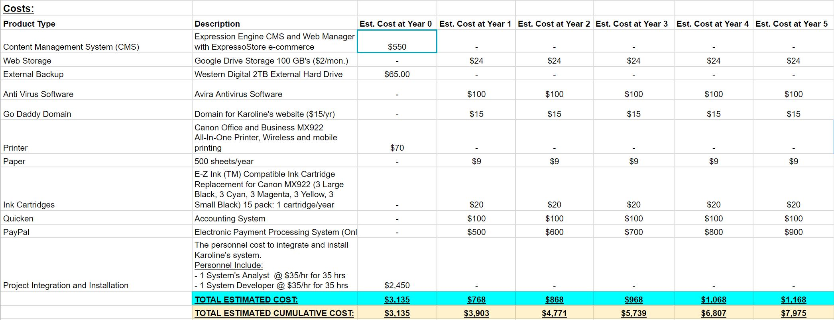

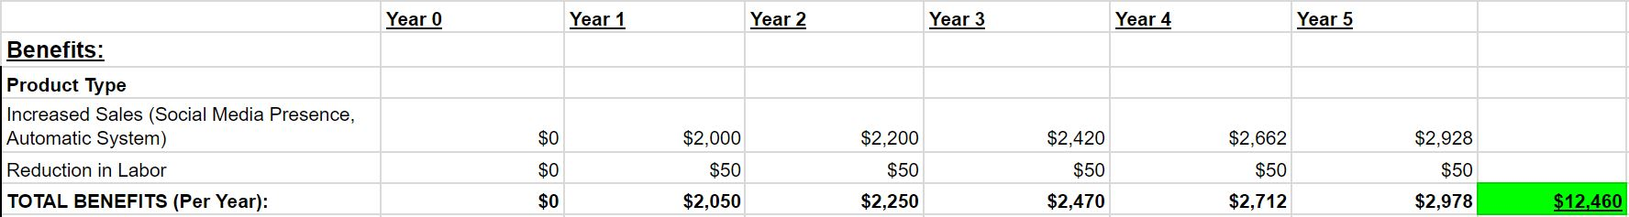

The two images that are displayed above make up the feasibility analysis. It compares the costs of the new system to the benefits to determine whether a project is feasible or not. Costs and benefits can either be tangible or intangible. Financial equations like Net Present Value, Return on Investment, and the Break Even Point are used to calculate how much money a project will make or lose within a certain period of time, and are important factors for determining a project’s feasibility. The results of the equations usually display the tangible costs and benefits.

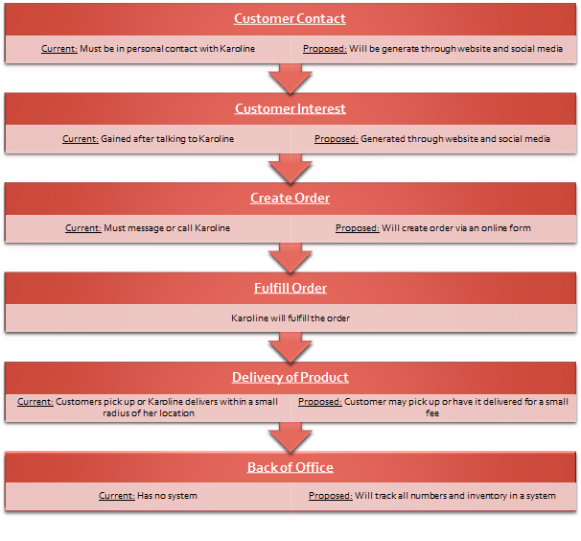

Listed above is the Business Process Model. For Sweet Karolines Cakes business, we will be automating the business using Business Process Automation. The business process will remain the same. It will begin with the customer contact, then move to generating customer interest, from there the customer will create an order. Karoline will then fulfil the order and will deliver the product and complete the back of office work. The difference from the current as-is, and the to-be is that customer contact will be generated online via the website and social media. Customer interest will be generated through the website and social media as well. An order will then be created from there and will be created via the use of an online form. Karoline will the fulfill the order like usual and have the product delivery. Karoline will then use a back of office system to track the information.

**System Requirements**

**System requirements- Narrative**

This section explains the requirements that the system should be able to handle, based on the business needs of the organization. Requirements have been divided into several categories and subcategories. The requirements are the bases for the use cases of the system.

**Functional Requirements:**

1. **Manage Customer Information** 
   1. System will ask customer if they want to create an account.
   2. System will allow customers to enter, modify, and delete personal information.
   3. System will allow customers to delete their account or personal information.
   4. System will encourage customers to follow Karoline on her social media platforms.
   5. System will allow customer to contact Karoline about potential questions.
2. **Manage Payment/Checkout System**
   1. System will allow customers selected items to be checked out.
   2. System will allow customers to set a delivery date.
   3. System will either accept or decline the customer’s purchase.
   4. System will use outsourced payment system.
   5. System will produce a receipt for a successful purchase.
   6. System will produce an error message if purchase is failed.
   7. System will send the customer an automated thank you email with receipt attached.
3. **Manage Customer Order** 
   1. System will notify Karoline about the Customer’s order.
   2. System will store the customer’s order.
4. **Manage Stakeholder Information** 
   1. System will allow Karoline to enter personal information and position in company.
   2. System will allow Karoline to create/upload files and documents.
   3. System will allow Karoline to delete files and documents.
   4. System will allow Karoline to modify information.
   5. System will allow Karoline to delete information.

**Non-Functional Requirements:**

1. **Information Management** 
   1. System will store Customer information into Customer database
   2. System will store the customer’s order in Customer orders database.
   3. System will store Stakeholder information into Stakeholder database
   4. System will track and store organization files and documents saved by Karoline.

**6. Manage Back Office**

6.1 System will allow Karoline to keep track of her inventory with Quicken accounting software.

6.2 System will allow Karoline to keep track of her finances with Quicken accounting software.

6.3 System will allow Karoline to see how her business is doing at a single point in time.

**Use Cases**

**Narrative:** A use case describes how the user interacts with the system to perform some activity, such as placing an order, making a reservation, or searching for information. Put simply, a use case is a generic action for a single process.

ID: 1

Criteria: Create Account

Actor: Customer

Description: Customer creates an account

ID: 2

Criteria: Edit Account

Actor: Customer

Description: Customer can edit customer account information

ID: 3

Criteria: Delete Account

Actor: Karoline, Sweet Karolines Cakes (SKC)

Description: SKC admin or the account admin (end-user) can delete account

ID: 4

Criteria: Create Order

Actor: Customer

Description: Customer submits order with order form

ID: 5

Criteria: Modify Order

Actor: Customer

Description: Customer modifies existing order by using additional modification request forms.

ID: 6

Criteria: Delete Order

Actor: Customer, Karoline, Sweet Karolines Cakes (SKC)

Description: Customer or SKC admin deletes an order from the database

ID: 7

Criteria: View Previous Orders

Actor: Karoline, Sweet Karolines Cakes (SKC)

Description: Account admin (end-user) and SKC admin can view previous orders made by end-user

ID: 8

Criteria: Fulfill Order

Actor: Karoline, Sweet Karolines Cakes (SKC)

Description: Order is fulfilled by Karoline while tracked within the database of the system under status of order.

ID: 9

Criteria: Terminate Employee

Actor: Karoline, Sweet Karolines Cakes (SKC)

Description: Employee is terminated in real-world and this data is reflected in the database and tracked within the employee history database.

ID: 10

Criteria: Hire Employees

Actor: Karoline, Sweet Karolines Cakes (SKC)

Description: SKC contracts employees for certain positions, these positions are tracked in the employee history database

ID: 11

Criteria: Ship Order

Actor: Karoline, Sweet Karolines Cakes (SKC)

Description: Order is shipped to customer while being monitored in the order fulfillment status section of the database.

ID: 12

Criteria: Order Supplies

Actor: Karoline, Sweet Karolines Cakes (SKC)

Description: SKC orders supplies. This creates data inputs into the supplies and inventory section of the database.

ID: 13

Criteria: Track supplies expense

Actor: Karoline, Sweet Karolines Cakes (SKC)

Description: SKC monitors inflows and outflows of materials used for the production of their goods.

ID: 14

Criteria: Update Website in Content Management System

Actor: Karoline, Sweet Karolines Cakes (SKC)

Description: SKC database admin would edit data within the CMS that applies to their website to update information

ID: 15

Criteria: Update order form products

Actor: Karoline, Sweet Karolines Cakes (SKC)

Description: SKC updates products on its order form to meet current business needs.

ID: 16

Criteria: Complete payment information

Actor: Customer

Description: End-user fills out payment information to complete order.

ID: 17

Criteria: Contact Karoline (via Form)

Actor: Customer

Description: Customer clicks on contact button to send an email to Karoline.

ID: 18

Criteria: Respond to Customer

Actor: Karoline, Sweet Karolines Cakes (SKC)

Description: SKC replies to customer messages and emails..

ID: 19

Criteria: Post on Social Media

Actor: Karoline, Sweet Karolines Cakes (SKC)

Description: SKC should explore local advertising opportunities in order to get the product and name out into the community.

ID: 20

Criteria: Collect Payment

Actor: Karoline, Sweet Karolines Cakes (SKC)

Description: Payment management system collects payment from customer.

ID: 21

Criteria: Process Payment

Actor: PayPal

Description: Customer pays for cake(s) through link on PayPal which is then processed by PayPal.

ID: 22

Criteria: Pay Employees

Actor: Karoline, Sweet Karolines Cakes (SKC)

Description: Any employees on payroll are paid via direct deposit.

ID: 23

Criteria: Request a Quote

Actor: Customer

Description: Customer requests a quote for an item from Karoline.

ID: 24

Criteria: Provide Quote

Actor: Karoline, Sweet Karolines Cakes (SKC)

Description: SKC responds to customer with the requested quote for an item.

ID: 25

Criteria: Add Item

Actor: Karoline, Sweet Karolines Cakes (SKC)

Description: Karoline adds an item to website store.

ID: 26

Criteria: Update Item

Actor: Karoline, Sweet Karolines Cakes (SKC)

Description: Karoline updates an existing item on the website store.

ID: 27

Criteria: Delete Item

Actor: Karoline, Sweet Karolines Cakes (SKC)

Description: Karoline deletes an existing item on the website store.

ID: 28

Criteria: Add Item to cart

Actor: Customer

Description: The customer will select an item they would like to add to an order.

ID: 29

Criteria: Record costs

Actor: Karoline, Sweet Karolines Cakes (SKC)

Description: SKC wants to track and record how much money they are using every week/month/year.

ID: 30

Criteria: Record income

Actor: Karoline, Sweet Karolines Cakes (SKC)

Description: SKC wants to track and keep records of how much money is being made every week/month/year.

ID: 31

Criteria: Record number of hours worked

Actor: Karoline, Sweet Karolines Cakes (SKC)

Description: SKC needs a way to record how many hours each employee has worked per week in order to understand how much money they should be paid for their work.

ID: 32

Criteria: View Information about Karoline

Actor: Customer

Description: Customer can view information about Karoline via Karolines website.

ID: 33

Criteria: Remove item from cart

Actor: Customer

Description: Customer removes an item from their cart.

ID: 34

Criteria: Update Cart

Actor: Customer

Description: The customer will update the quantity of items in their cart.

ID: 35

Criteria: Delete Cart

Actor: Customer

Description: The customer will delete their cart by completing the order.

ID: 36

Criteria: Input Shipping Information

Actor: Customer

Description: The customer enters their shipping information to where they want their products to be delivered.

ID: 37

Criteria: Display product information

Actor: SKC

Description: SKC displays pictures and descriptions of their products

ID: 38

Criteria: Edit product examples/information

Actor: Karoline, SKC

Description: SKC will update and edit product display pictures and descriptions of her products.

ID: 39

Criteria: Delete product information

Actor: SKC

Description: SKC will delete displays of their products

ID: 40

Criteria: View business information

Actor: SKC, Customer

Description: SKC displays information about the business. Includes hours of operation, delivery times, and location. Customer views said information after it is posted.

ID: 41

Criteria: Edit business information

Actor: SKC

Description: SKC edits the displays of information about the business. Includes hours of operation, delivery times, and location.

ID: 42

Criteria: Delete business information

Actor: SKC

Description: SKC removes the information about the business from the website. Includes hours of operation, delivery times, and location.

**System Architecture:** The diagram below demonstrates the interactions between Karoline, the system, and the customer. PMS = Payment Management System, DBMS = Database Management System.

.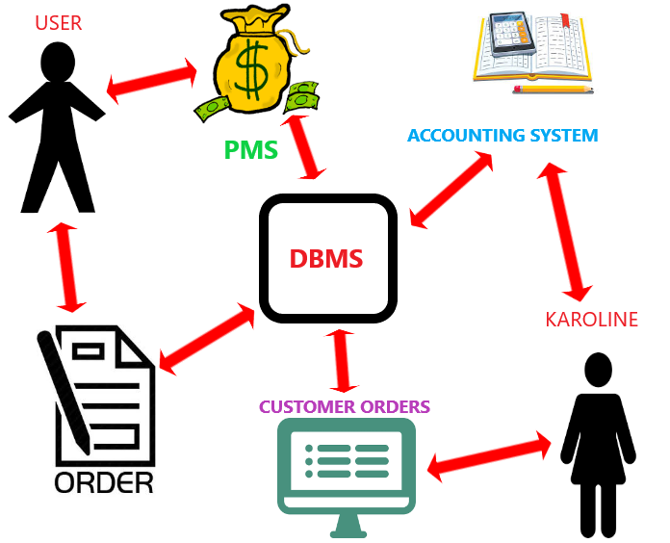

**Initial Architecture Considerations**

**Narrative:** This document displays the initial ideas for the system architecture. The design viewpoints were created on the basis that the customer and Sweet Karoline’s Cakes were most likely going to take these courses of action upon completion of the website, and that they are the most important use cases.

‘Basic Setup’

Design Viewpoint:

1. Customer enters website, browses options
2. Selects order form and enters information
3. Customer inputs payment method and/or communicates with Karoline
4. Order is submitted
5. Karoline accesses website
6. Views orders to complete and customer information
7. Order and info are stored in website database and personal device
8. Customer enters website, decides to sign up for an account
9. Selects sign up, enters information
10. Account info is stored in website database and can be viewed by Karoline.
11. Customer submits member order form

Realization Viewpoint

1. Customer enters website

**Risk Analysis**

The risk analysis reviews each of the expected risk each for each individual use case. The risks are categorized by either high or low risks. These risks are assessed by Silver Soul, these assessments depend on their effect on the Sweet Karoline’s Cakes. Upon completion of the risk level assessment, the description of the risk is documented. Soul Silver then documents and explains the risk, and how it affects individual actors for each use case.

ID: 1

Title:Create Account

Criteria: How will adding a volunteer affect SKC’s data?

Risk Level: Low

Risk: Inputting incorrect data could cause issues with accessing the website but can easily be corrected

ID: 2

Title: Edit Account

Criteria: How will editing account data affect SKC’s data

Risk level: Low

Risk: may create edit anomalies leading to minor data redundancy

ID: 3

Title: Delete Account

Criteria: How will deleting account data affect SKC’s data

Risk level: Low

Risk: may create delete anomalies leading to minor data redundancy

ID: 4

Title: Create Order

Criteria: How will creating an order affect SKC

Risk level: High

Risk: inefficiently collecting data my lead to incorrect order or order fulfillment

ID: 5

Title: Modify Order

Criteria: will modifying order impact SKC

Risk Level: Low

Risk: modifying the order may lead to problems with order fulfillment

ID: 6

Title: Delete Order

Criteria: will deleting order impact SKC

Risk Level: Low

Risk: accidently deleting an order or deleting the incorrect order

ID: 7

Title: View Previous Orders

Criteria: will viewing previous orders impact SKC data

Risk level: low

Risk: viewing previous order data presents minimal risk

ID: 8

Title: Fulfill Order

Criteria: How does fulfilling orders impact SKC data

Risk level: High

Risk: order fulfillment is critical to day to day business as well as tracking of the information

ID: 9

Title: Terminate Employee

Criteria: How does terminating an employee impact SKC data

Risk level: low

Risk: terminating employees may lead to data redundancies in the database on employee data

ID: 10

Title: Hire Employees

Criteria: How does hiring employees impact SKC’s data

Risk level: low

Risk: hiring employees may lead to incorrect data being stored or problems with properly storing employee data

ID: 11

Title: Ship Order

Criteria: How does shipping an order impact SKC’s data

Risk level: High

Risk: Properly shipping an order and tracking and logging this information is critical to SKC business and data

ID: 12

Title: Order Supplies

Criteria: How does ordering supplies impact SKC’s data

Risk level: high

Risk: not properly ordering or tracking supplies negatively impacts SKC and it’s data

ID: 13

Title: Track supplies expense

Affect SKC’s data

Risk level: High

Risk: tracking supplies’ expenses is critical to SKC’s business and data

ID: 14

Title: Update Website in Content Management System

Criteria: How does updating the Website affect SKC

Risk level: Low

Risk: not properly updating the website could lead to difficulties with the business, but we are are not projecting any drastic changes in the immediate future

ID: 15

Title: Update order form products

Criteria: How does having a properly updated order form affect SKC

Risk level: High

Risk: Not having properly updated order information on the site will allow for invalid orders to be made leading to a myriad other complications

ID: 16

Title: Complete payment information

Criteria: How does end-users completion of payment forms affect SKC

Risk level: high

Risk: completing the payment information accurately allow for transactions to take place, thus is critical

ID: 17

Title: Contact Karoline (via Form)

Criteria: How does contacting Karoline affect SKC

Risk Level: low

Risk: although contacting Karoline may be important now, our desired outcome is to reduce the need for this communication, meaning that the need to contact Karoline directly will have less risk for the company

ID: 18

Title: Respond to Customer

Criteria: how does responding to consumer inquiries affect SKC

Risk level : Low

Risk: communication is key, but does not have devastating impacts on order completion or data integrity

ID: 19

Title: Post on Social Media

Criteria: How does posting to social media platforms affect SKC

Risk level: High

Risk: Social Media is a key method of communicating with SKC’s current consumer base so being able to access these platforms and use the effectively is key

ID: 20

Title: Collect Payment

Criteria: How does collecting payments affect SKC

Risk level: high

Risk: collecting payments and tracking the transactional data is critical to the business

ID: 21

Title: Process Payment

Criteria: how does processing payments affect SKC

Risk Level: High

Risk: Processing payments is critical for online transactions

ID: 22

Title: Pay Employees

Criteria: how does paying employess impact SKC

Risk level: Low

Risk: Paying employees is important to maintaining these employees. This data should be tracked

ID: 23

Title: Request a Quote

Criteria: how does consumers ability to request a quote affect SKC

Risk level: Low

Risk: Consumers may want specialty orders and requesting a quote can allow them to make a decision on a purchase

ID: 24

Title: Provide Quote

Criteria: How does SKC’s ability to provide a quote affect their business

Risk level: low

Risk: an accurate quote may guide a consumer towards a purchase

ID: 25

Title: Add Item

Criteria: how does skc’s ability to add items impact their business

Risk level: Low

Risk: as the business changes SKC will want to add items to their menu

ID: 26

Title: Update Item

Criteria: how does skc’s ability to update items impact their business

Risk level: Low

Risk: As the business changes SKC will want to update items

ID: 27

Title: Delete Item

Criteria: how does skc’s ability to delete items impact their business

Risk level: Low

Risk: As the business changes SKC will want to deleteitems

ID: 28

Title: Add Item to cart

Criteria: How does end-users add item to cart affect SKC

Risk Level: High

Risk: Without this ability online purchases cannot be made

ID: 29

Title: Record costs

Criteria: How does recording costs impact SKC’s data

Risk level: High

Risk: Recording costs are critical for making sure SKC is profitable

ID: 30

Title: Record income

Criteria: How does recording income impact SKC’s data

Risk level: High

Risk: Recording income is critical for making sure SKC is profitable

ID: 31

Title: Record number of hours worked

Criteria: How does recording hours worked impact SKC’s data

Risk level: High

Risk: Recording hours worked is critical for making sure SKC is profitable

ID: 32

Title : View Information about Karoline

Criteria: How does viewing information about Karoline affect SKC

Risk level : Low

Risk: Some consumers may be more persuaded to make a purchase if an about the owner information is offered.

ID: 33

title: Remove item from cart

Criteria: How does an end-users ability to remove a cart item affect SKC

Risk Level: High

Risk: Removing and adding items to a cart is critical for end-users utilizing the website for transactions

ID: 34

Criteria: Update Cart

Criteria: How does an end-users ability to update a cart item affect SKC

Risk Level: High

Risk: Removing and adding items to a cart is critical for end-users utilizing the website for transactions

ID: 35

Criteria: Delete Cart

Criteria: How does an end-users ability to delete a cart item affect SKC

Risk Level: High

Risk: Removing and adding items to a cart is critical for end-users utilizing the website for transactions

ID: 36

Title : Input Shipping Information

Criteria: How does an end user effectively inputing their shipping information affect SKC

Risk level: High

Risk: without the proper shipping information than it may be difficult to complete an order.

ID: 37

Title:Display product information

Criteria: How does displaying the product information on their webpage affect SKC

Risk level: low

Risk: Inaccurate product information will lead to unwanted consumer purchases

ID: 38

Title: Edit product examples/information

Criteria: How does SKC’s ability to edit product examples/info affect them.

Risk level: low

Risk: SKC will want to accurately display information about the products it is selling

ID: 39

Title: Delete product information

Criteria: How does SKC’s ability to delete product info affect them.

Risk level: low

Risk: SKC will want to accurately display information about the products it is selling

ID: 40

Title: Display business information

Criteria: How does SKC’s ability display its business information affect them.

Risk level: low

Risk: SKC will want to accurately display information about its business

ID: 41

Title: Edit business information

Criteria: How does SKC’s ability edit its business information affect them.

Risk level: low

Risk: SKC will want to accurately edit information about its business

ID: 42

Title: Delete business information

Criteria: How does SKC’s ability delete its business information affect them.

Risk level: low

Risk: SKC will want to accurately delete information about its business

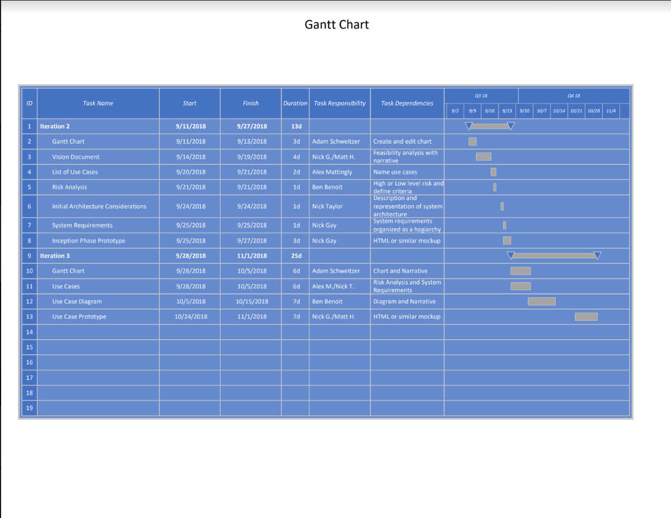

**Model - Gantt Chart:** In the Gantt chart, horizontal bars are drawn to represent the duration of each task, and as people work on tasks, the appropriate bars are filled in proportionately to how much of the task is finished.

**Prototype - Homepage:** The following image was created to give Sweet Karoline’s an idea of what the homepage of the website may look like. It includes tabs for the home page, order form, the menu, a gallery for photos of products, an about page, and the contact page. 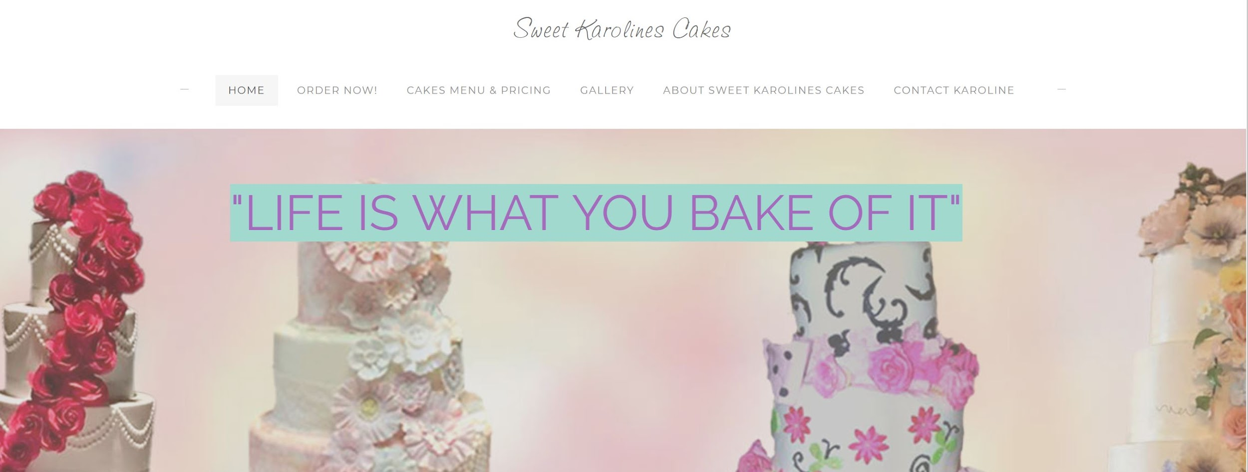

**Prototype - Order Form:** This is a basic prototype of what the order form will look like when the website is completed. It contains many fields that need to be filled with customer information. There is also a text box for any additional information, a calendar that lists available order dates, and the form gives the customer an option to upload a photo to give Karoline a better idea of what they want. Despite aesthetics, however, the main purpose of this form is to allow the customer to make an order, and it is designed in a way to make this an easy process.

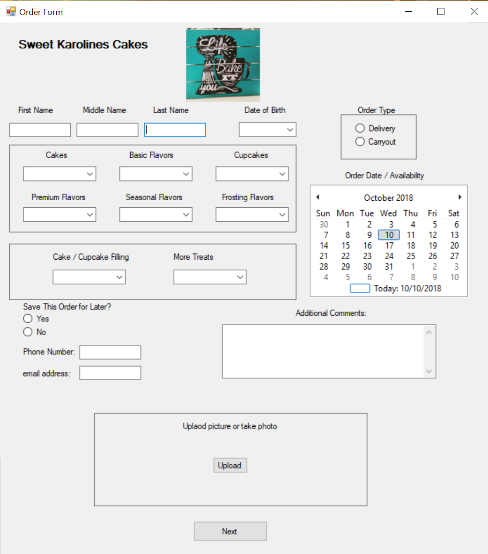

**Prototype - Payment Form:** This is a basic prototype of what the payment form will look like when the website is completed. Paypal will be the sole method of payment that is accepted, so it is displayed at the top of the form. The symbols for the various credit card companies signify that they are all processed through paypal. Since it can be a liability, Sweet Karoline’s website will not handle credit card information directly. The rest of the form consists of an order summary that displays the type of product that was ordered and the total cost. 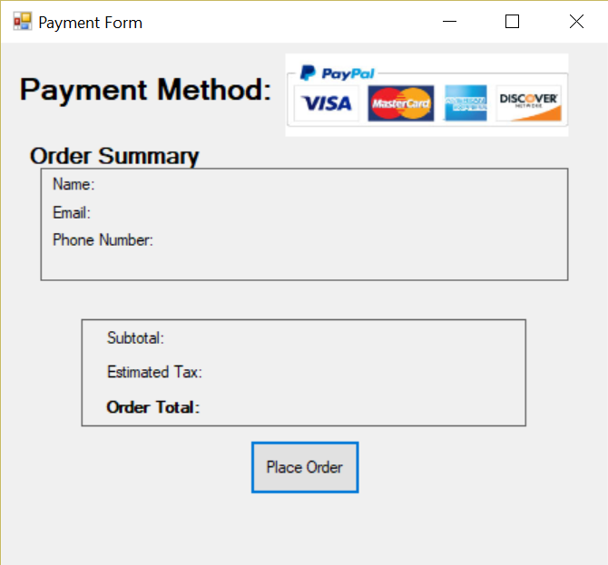

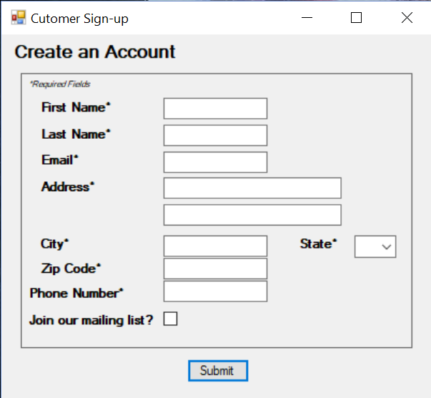

**Prototype - Account Setup:** This is a basic prototype of what the account creation form will look like when the website is completed. Nearly all of the fields require the customer to enter their information to create an account with Sweet Karoline’s Cakes. The form also includes an option to join a mailing list.

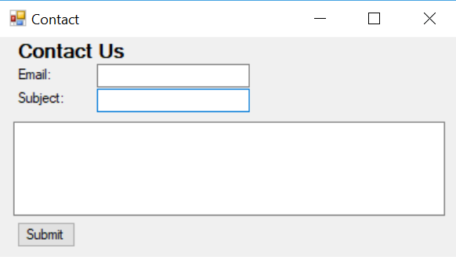

**Prototype - Contact Form:** This is a basic prototype of what the contact form will look like when the website is completed. The customer will enter their email, add a subject, and compose their message. The contact form will forward all messages to the administrative email.